**BUILD A PYTHON CODE , ASSUM EYOU GET A TEMPERATURE AND HUMIDITY VALUES GENERATED WITH RANDOM FUNCTION TO A VARIABLE AND WRITE A CONDITION TO CONTINUOUSLY DETECT ALARM IN CASE OF HIGH TEMPERATURE.**

**PYTHON CODE:**

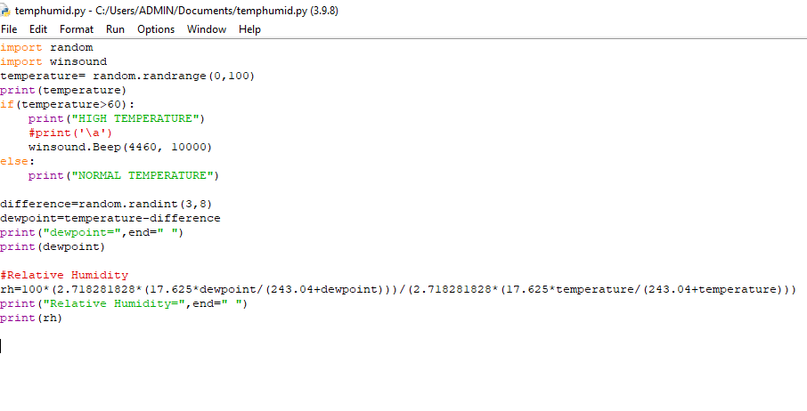

**OUTPUT:**

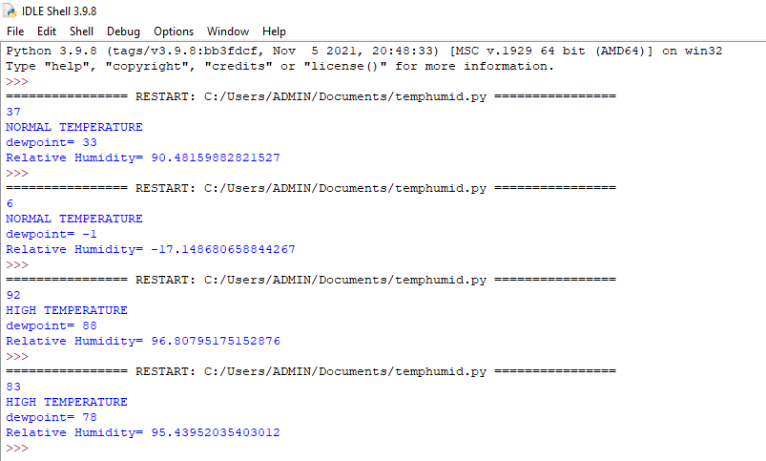

**DRIVE LINK:**

**https://drive.google.com/file/d/1s9TuLwrNhsUjovjKMcKLvkHY79oqqcaj/view?usp=sharing**